**Shell Scripting**

**LAB # 3 & 4**



**Spring 2021**

**CSE204L Operating System**

Submitted by: **Ashfaq Ahmad**

Registration No: **19PWCSE1795**

Class Section: **B**

“On my honor, as student of University of Engineering and Technology, I have neither given nor received unauthorized assistance on this academic work.”

Student Signature: ______________

Submitted to:

**Engr. Mian Ibad Ali Shah**

May 7 , 2021

**Department of Computer Systems Engineering**

**University of Engineering and Technology, Peshawar**

**Lab 4 Examples**

**Example no: 1**

**Input:**

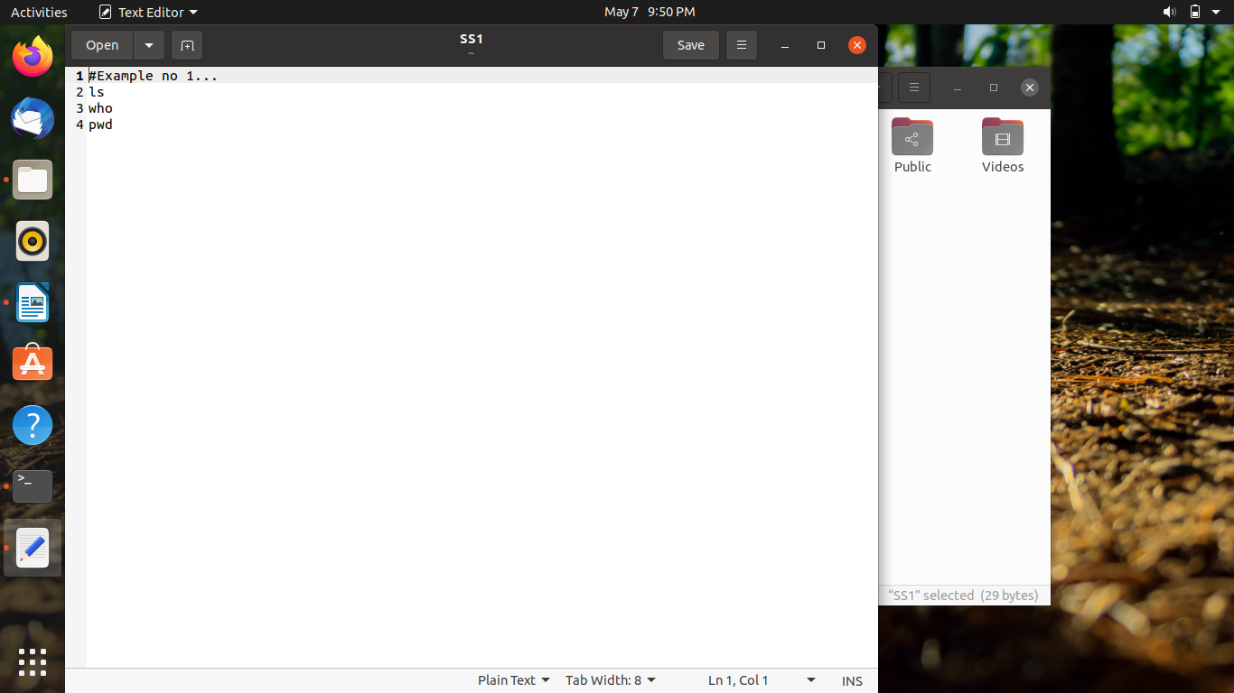

**Output:**

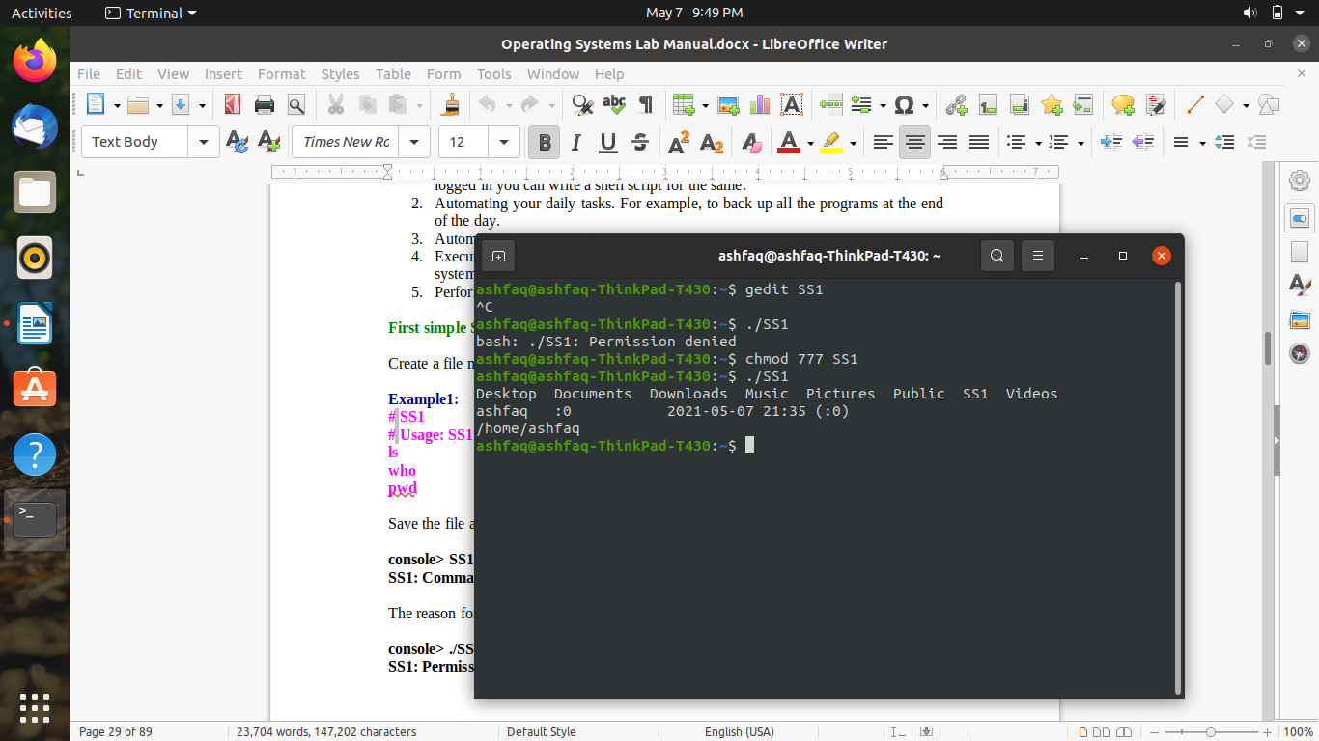

**Example no: 2**

**Input:**

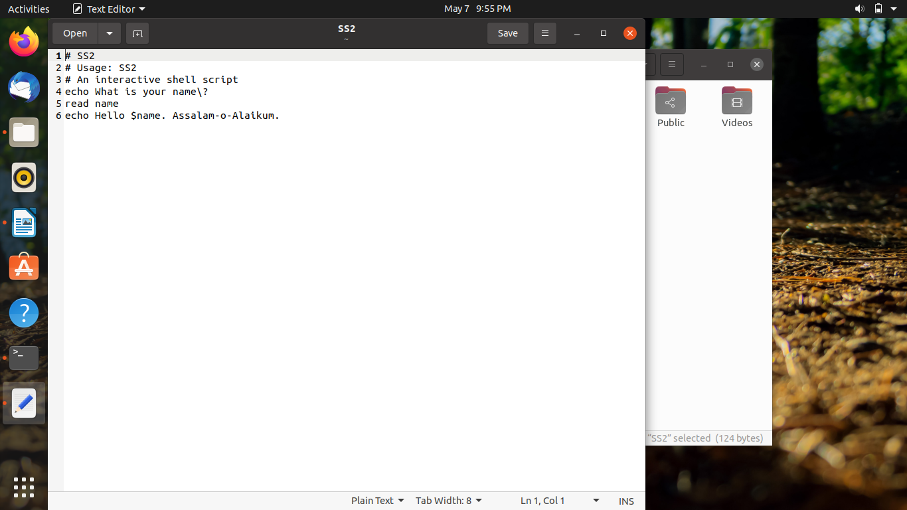

**Output:**

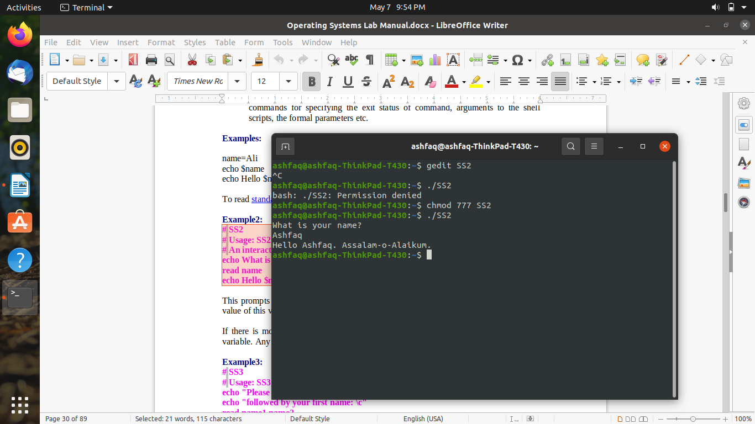

**Example no: 3**

**Input:**

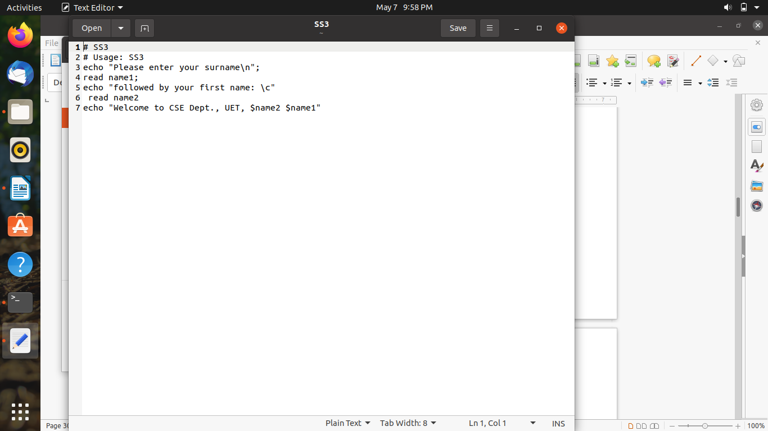

**Output:**

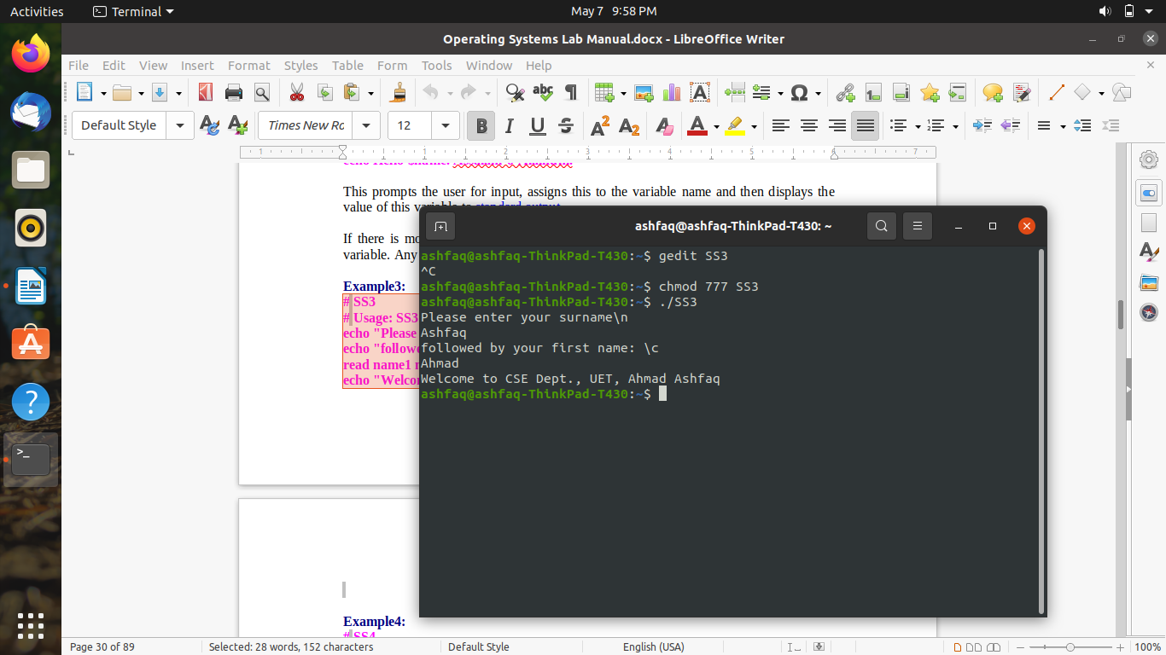

**Example no: 4**

**Input:**

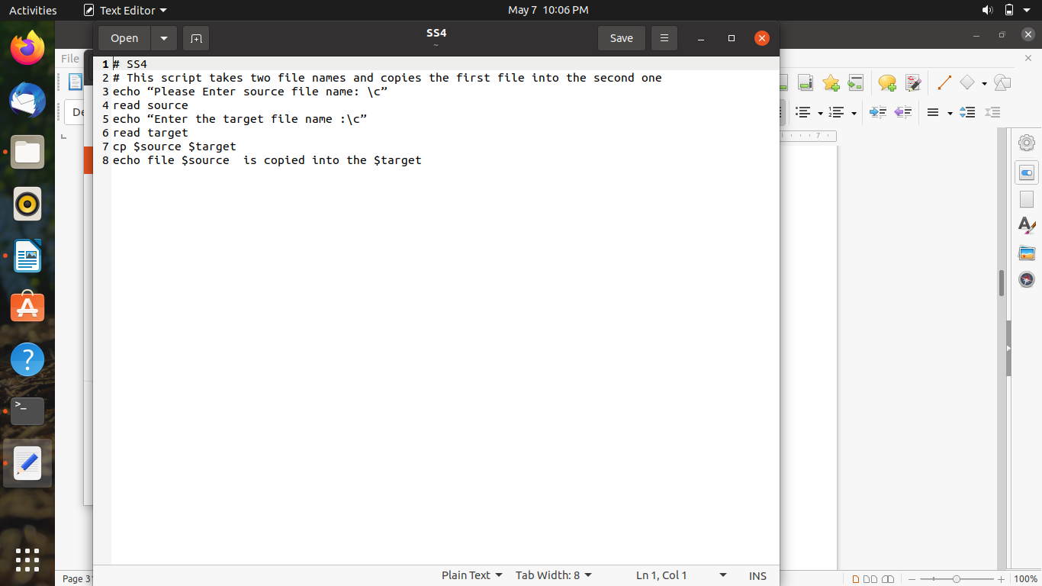

**Output:**

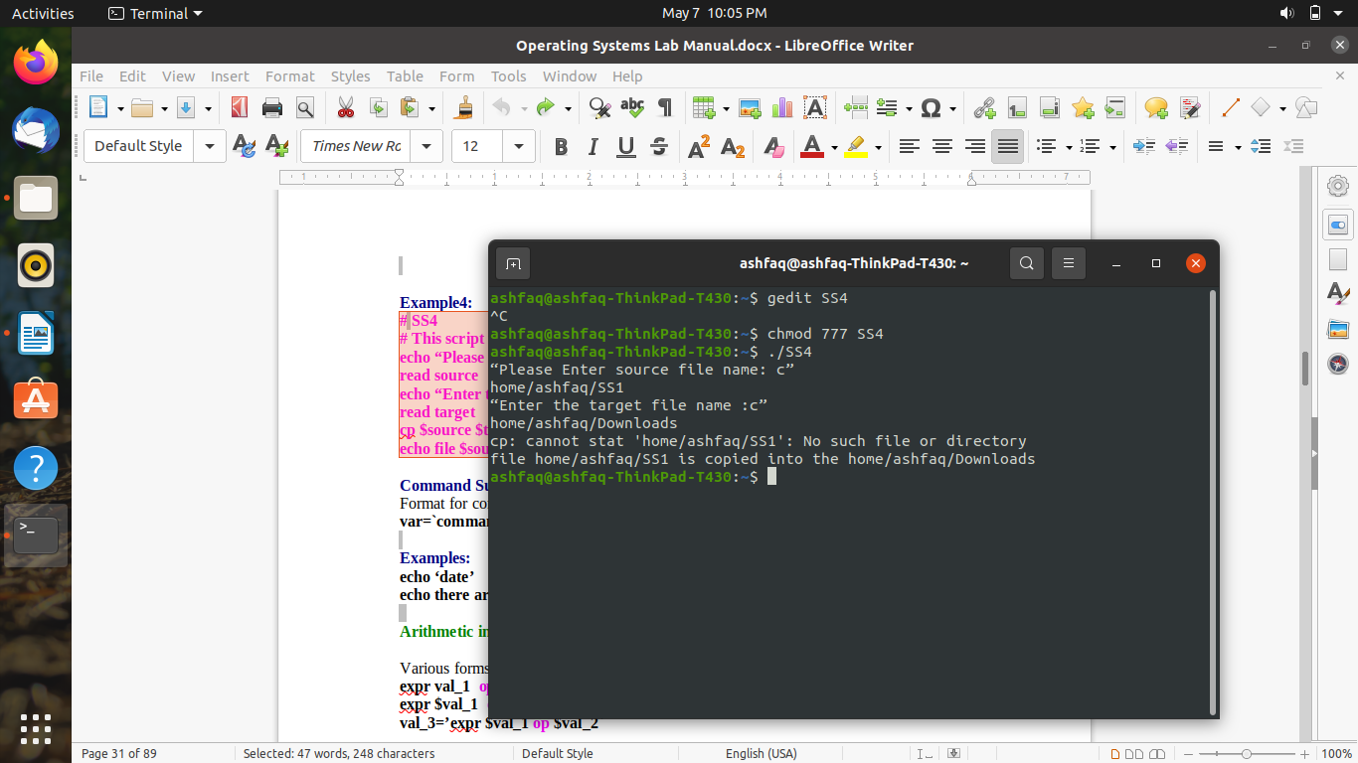

**Example no: 5**

**Input:**

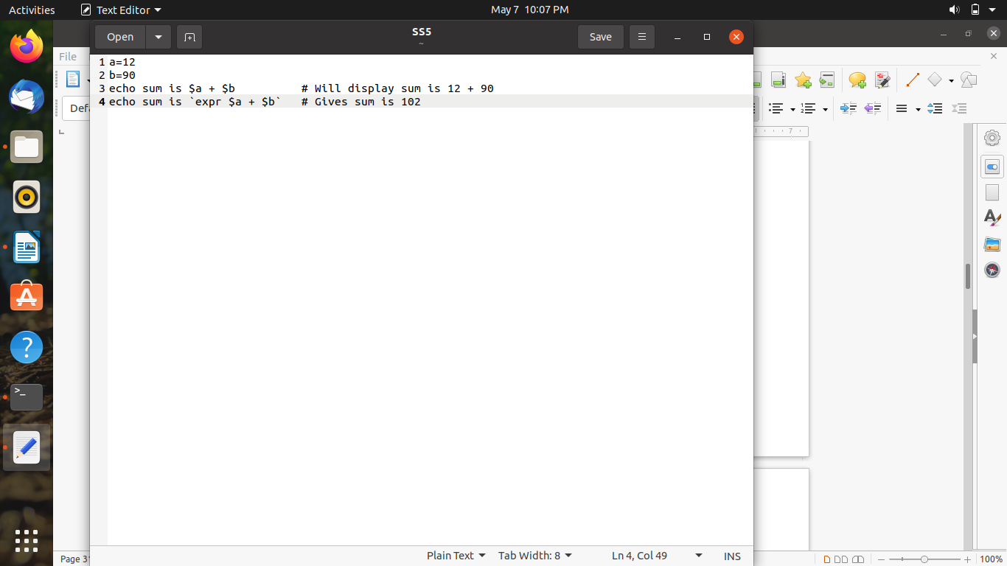

**Output:**

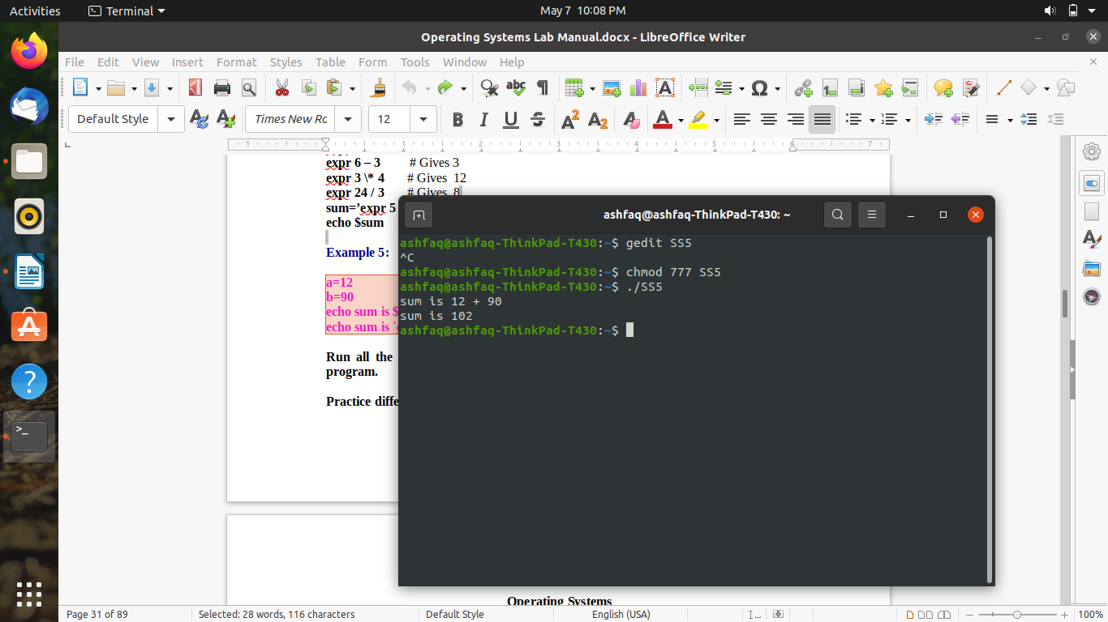

**Lab 5 Examples**

**Example no: 1**

**Input:**

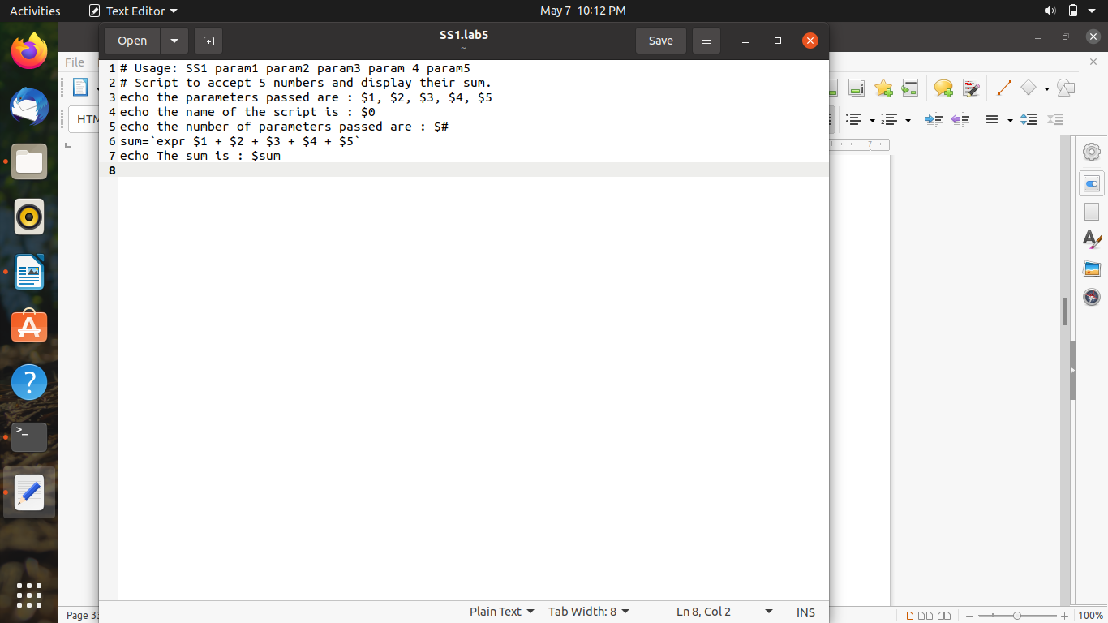

**Output:**

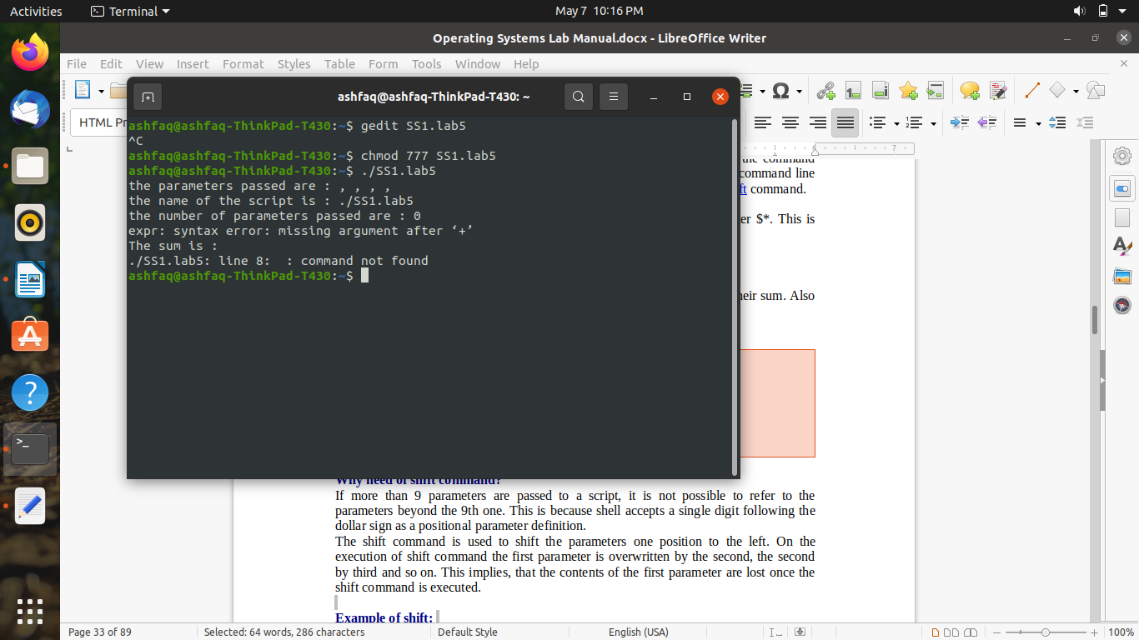

**Example no: 2**

**Input:**

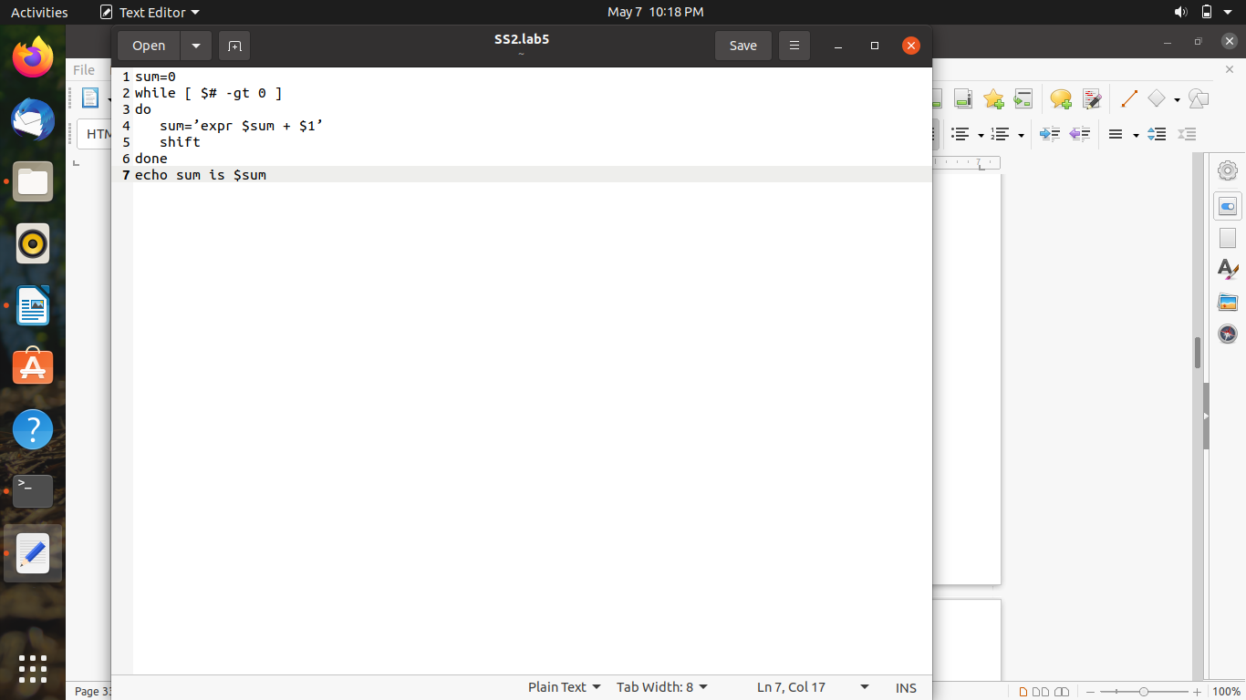

**Output:**

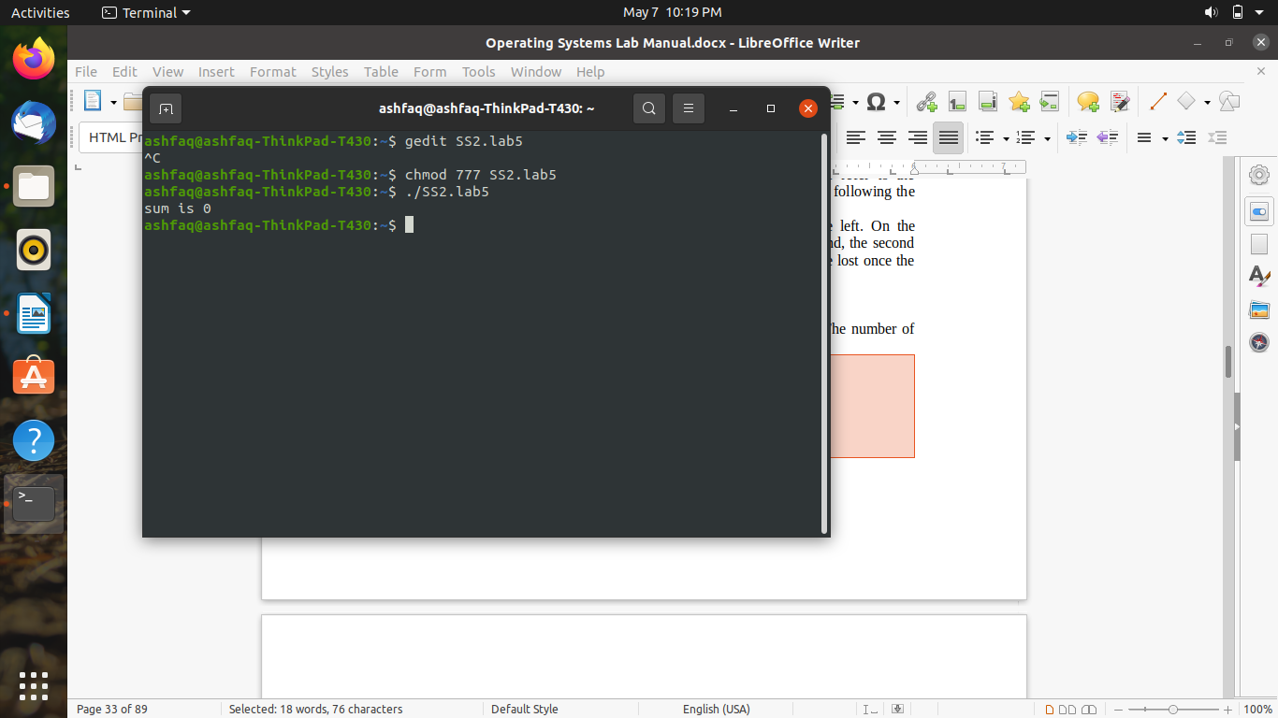

**Example no: 1**

**Input:**

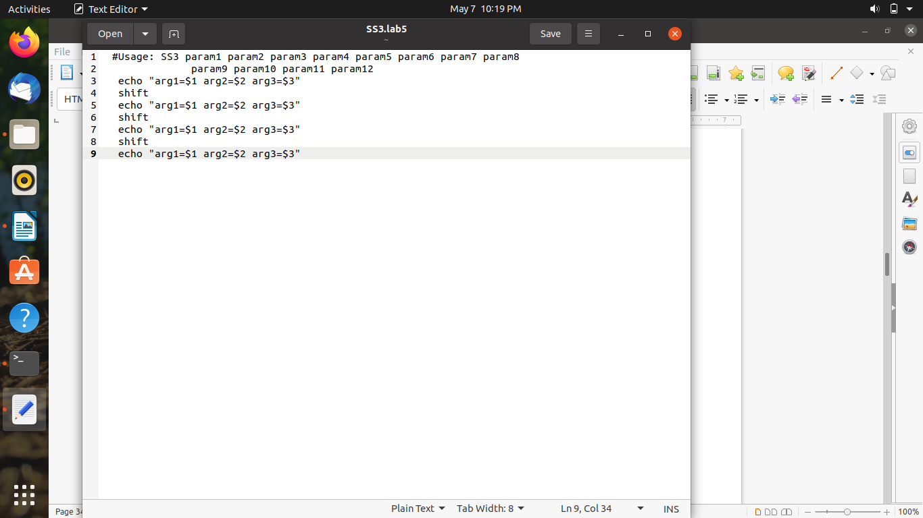

**Output:**

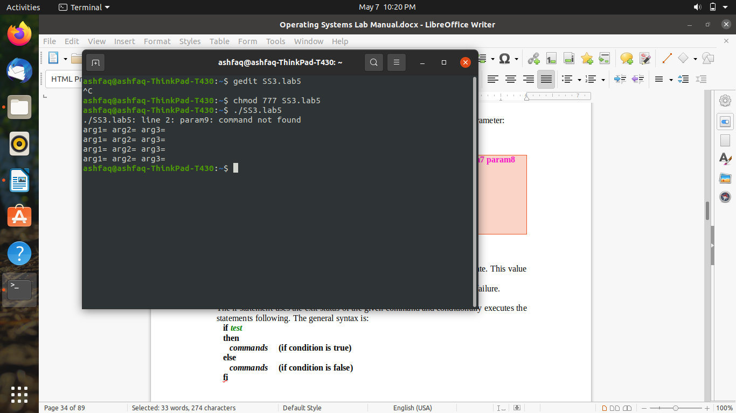

**Example no: 3**

**Input:**

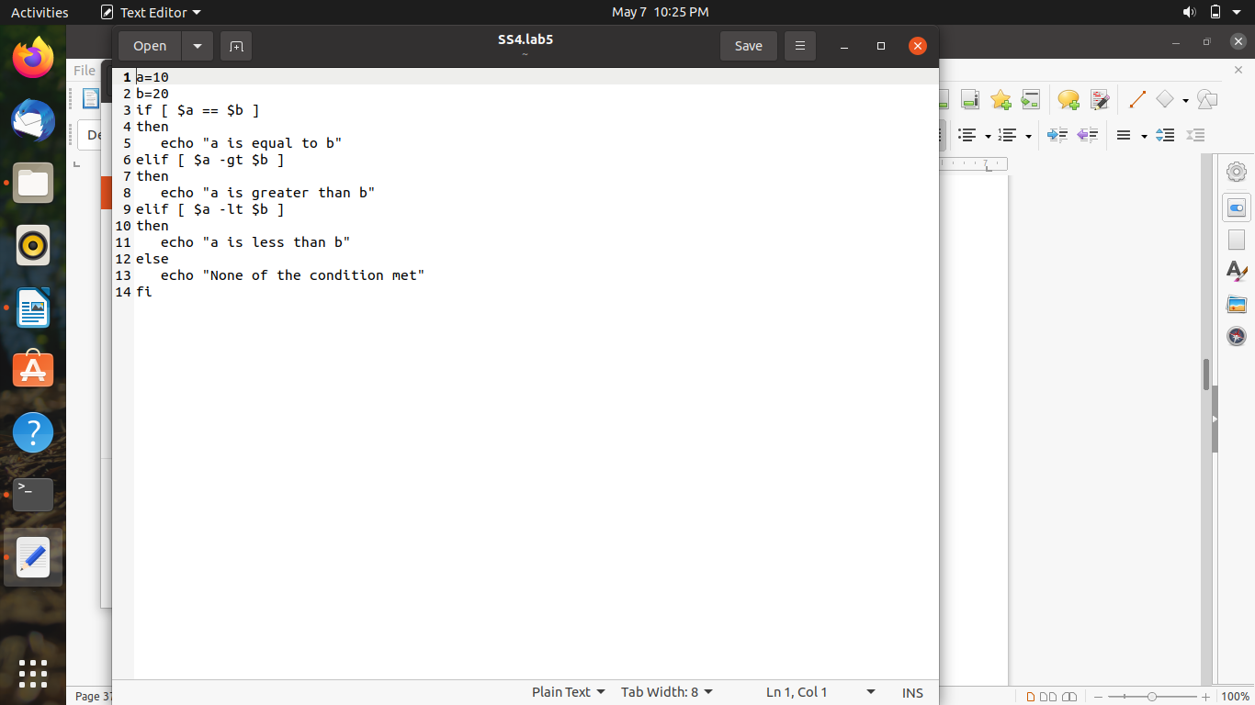

**Output:**

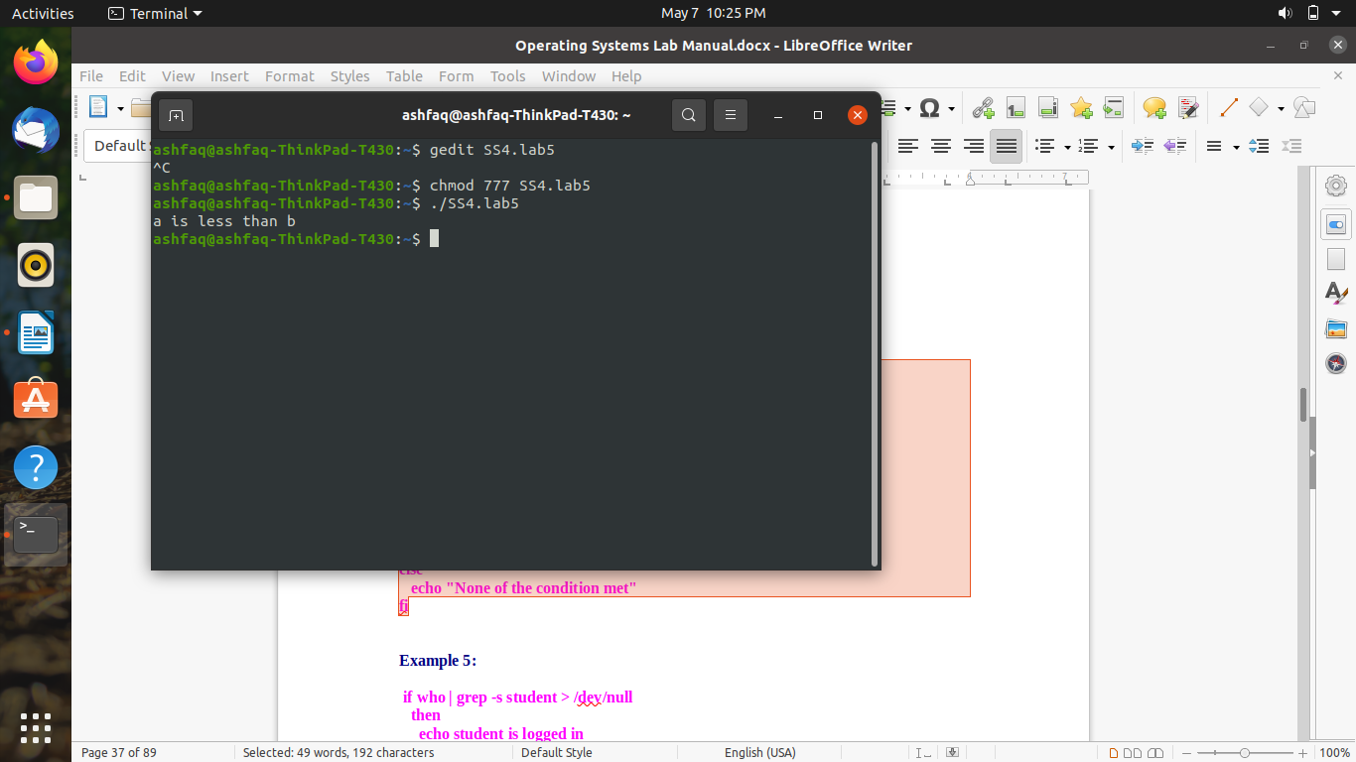

**Example no: 4**

**Input:**

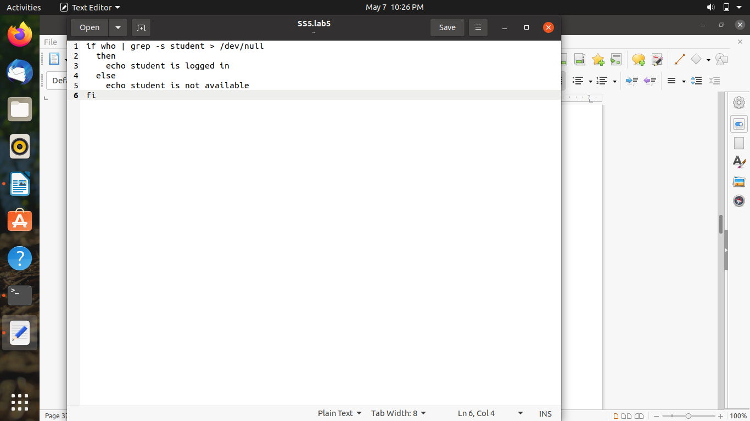

**Output:**

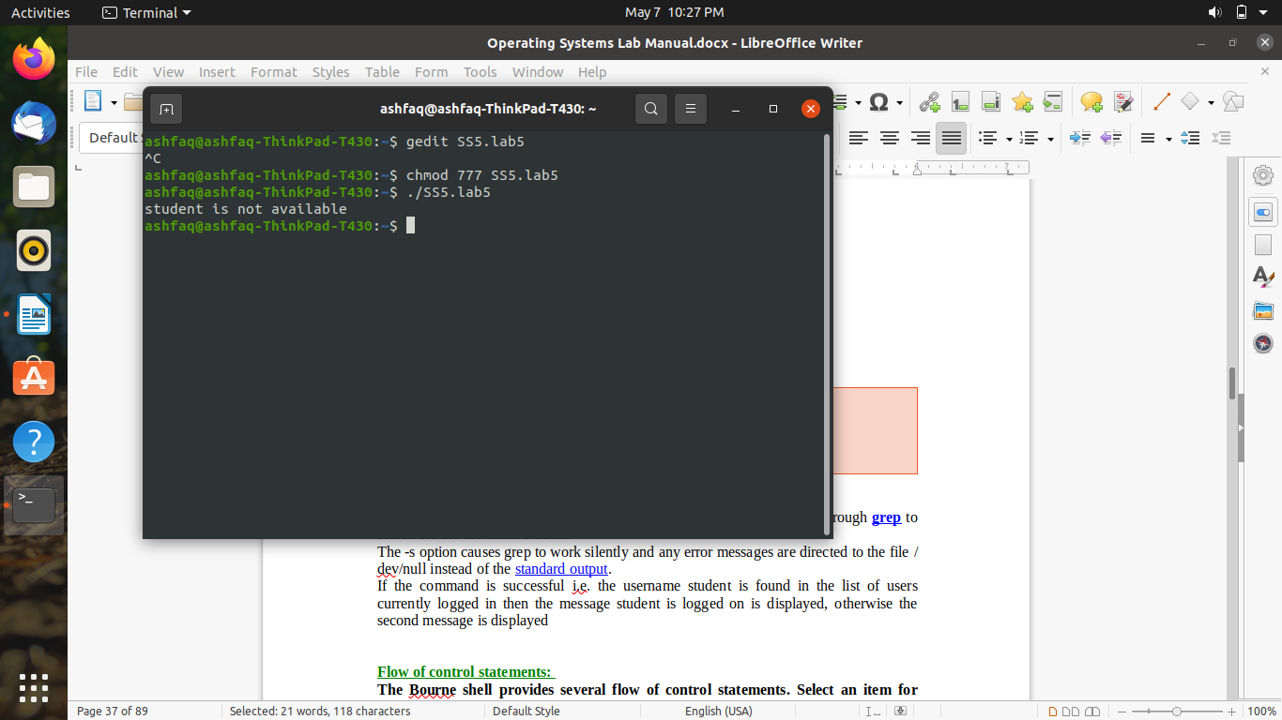

**Example no: 5**

**Input:**

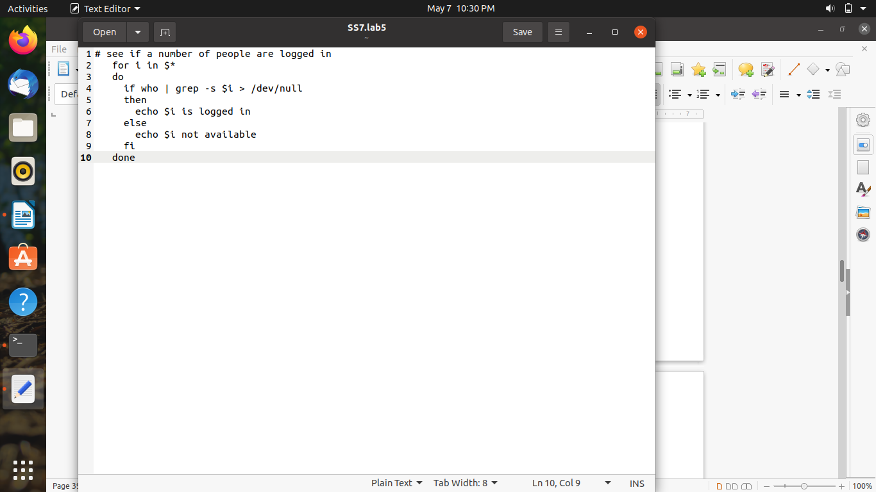

**Output:**

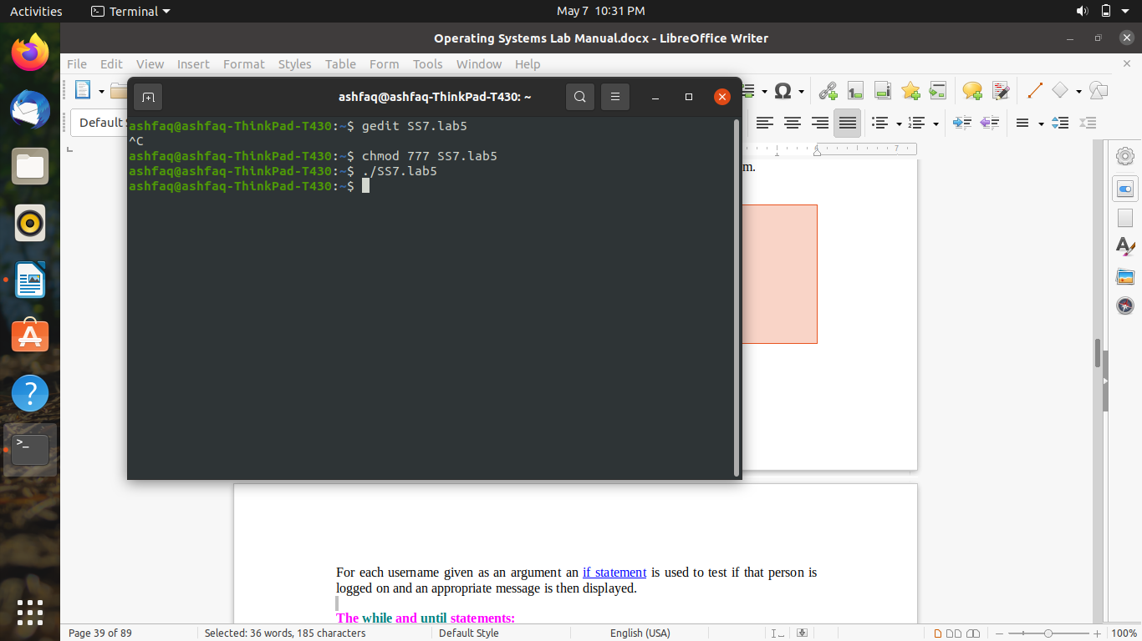

**Example no: 6**

**Input:**

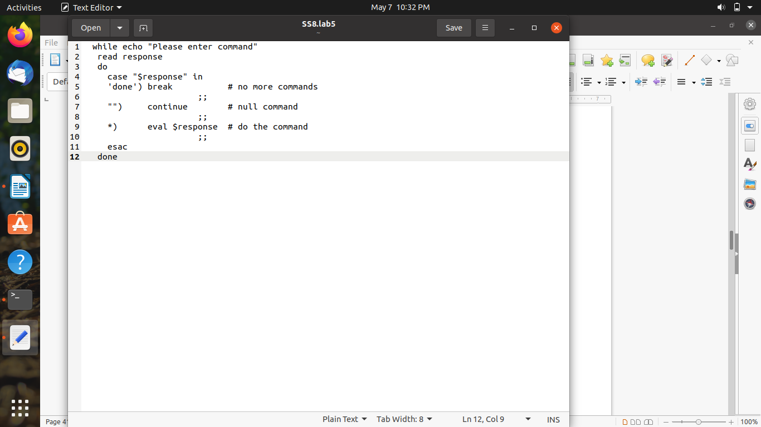

**Output:**

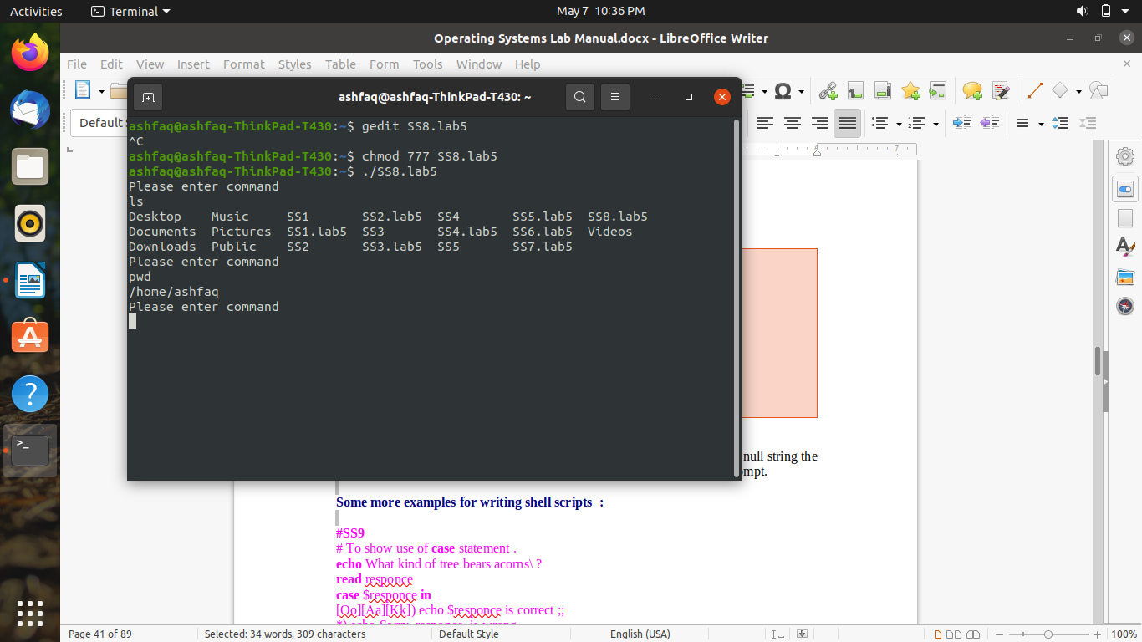

**Example no: 7**

**Input:**

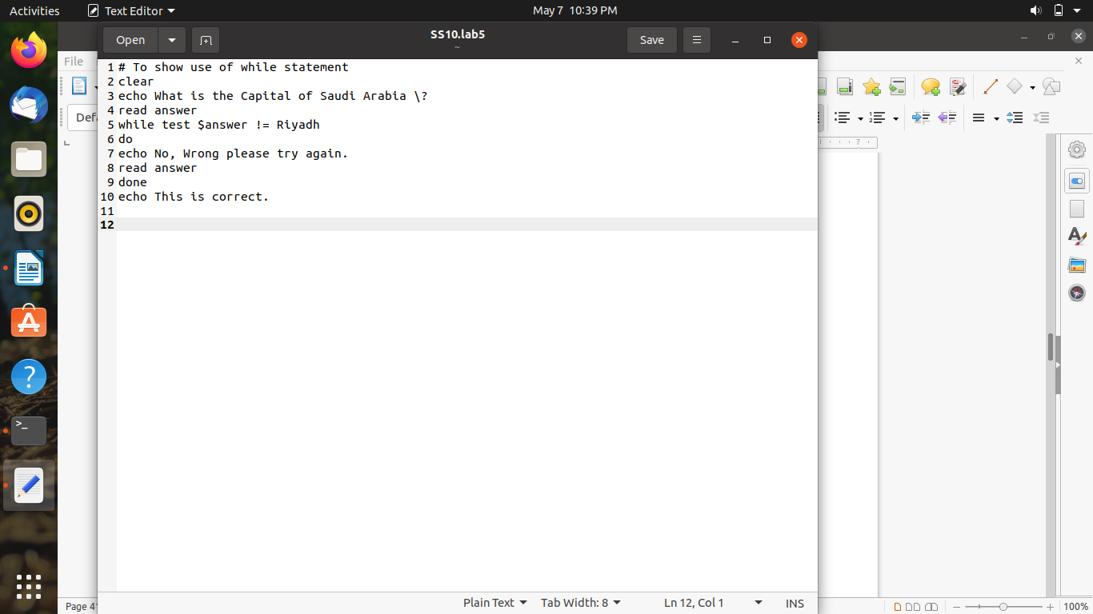

**Output:**

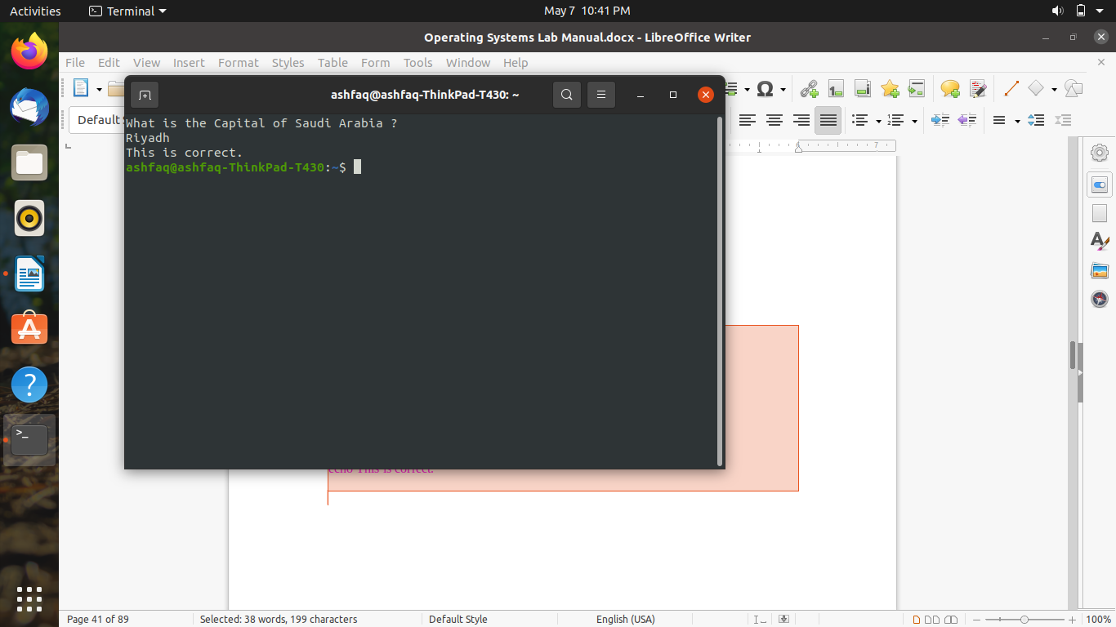

**Example no: 8**

**Input:**

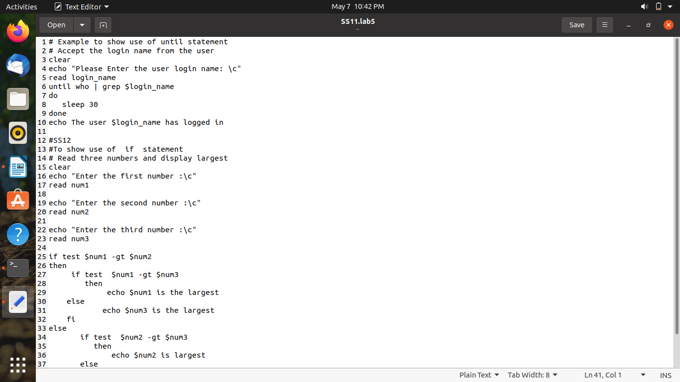

**Output:**

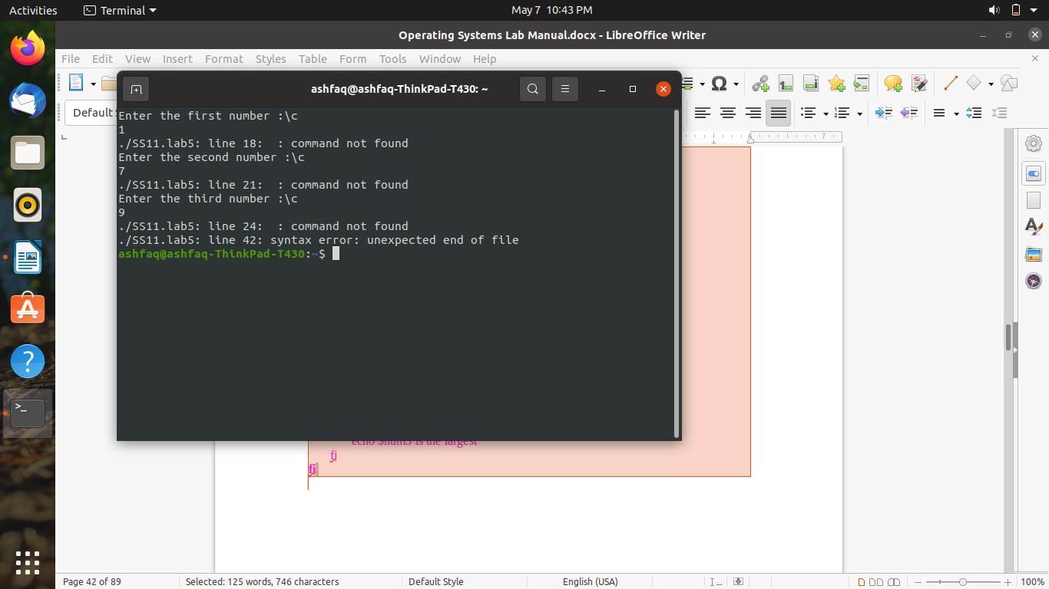

**Assignment Problems on UNIX SHELL programming**

1. Run all the programs given in the Lab Notes, and observe the output for each program.

Already done.

1. Write a shell script that takes a keyword as a command line argument and lists the filenames containing the keyword.

**Source code:**

echo Enter a world

read usr

echo `list *$usr*`

1. Write a shell script that takes a command line argument and reports whether it is a directory, or a file or a link.

**Source code:**

echo enter name

read a

if [ -f “$a” ]

then

echo file

elif [ -L “$a” ]

then

echo link

elif [ -d “$a” ]

then

echo Directory

else

echo No such file or directory or link

fi

1. Write a script to find the number of sub directories in a given directory.

**Source code:**

echo `pwd`

echo enter directory name

read di

echo `find $di –type –d | wc –l`

 5. Write a menu driven program that has the following options.

        5.1. Search a given file is in the directory or not.

        5.2. Display the names of the users logged in.

**Source code:**

echo “Enter 0 for users and 1 for file”

read inp

if [ inp –eq 0]

then

echo `who`

elif [inp –eq 1]

then

read fil

if [ -f fil ]

then

echo exists

else

echo does not exist

fi

else

echo wrong option

fi

**The End**